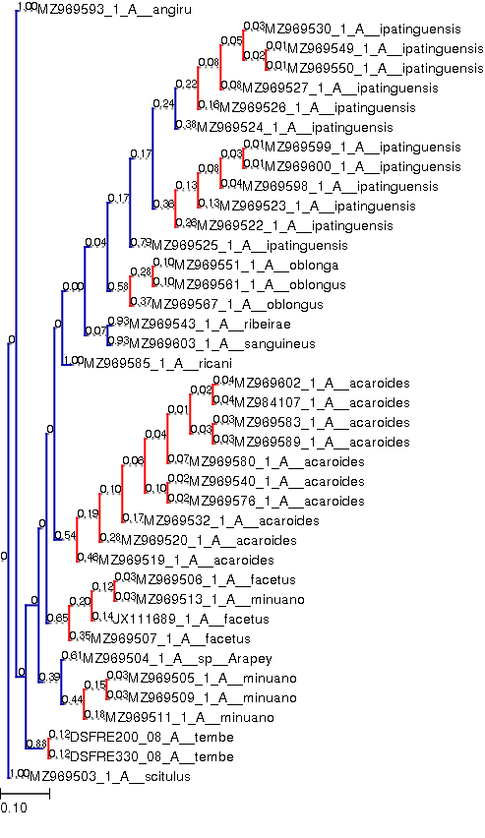
Fig. S1-1. Species delimitation result of analysis 1 for the COI gene, using Australoheros scitulus as outgroup, according to the bPTP method. *Blue lines represent delimited species and red lines represent intraspecific coalescence events.
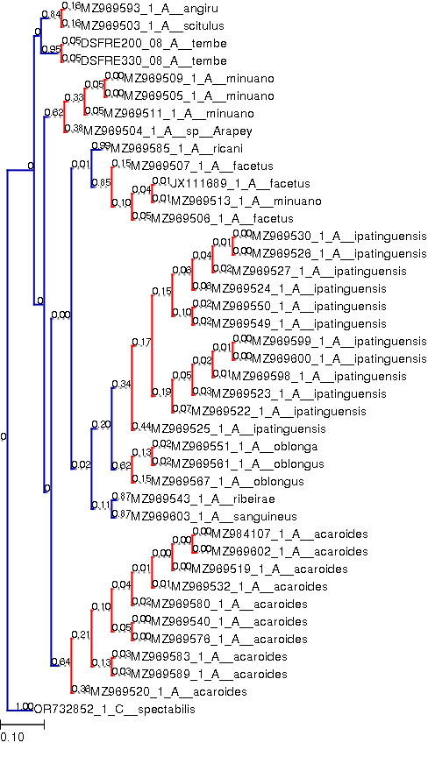
Fig. S1-2. Species delimitation result of analysis 2 for the COI gene, using Caquetaia spectabilis as outgroup, according to the bPTP method. *Blue lines represent delimited species and red lines represent intraspecific coalescence events.
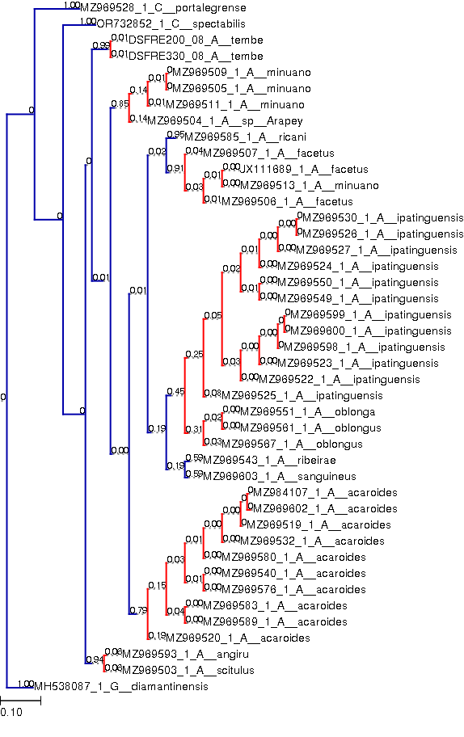
Fig. S1-3. Species delimitation result of analysis 3 for the COI gene, using Cichlasoma portalegrense as outgroup, according to the bPTP method. *Blue lines represent delimited species and red lines represent intraspecific coalescence events.
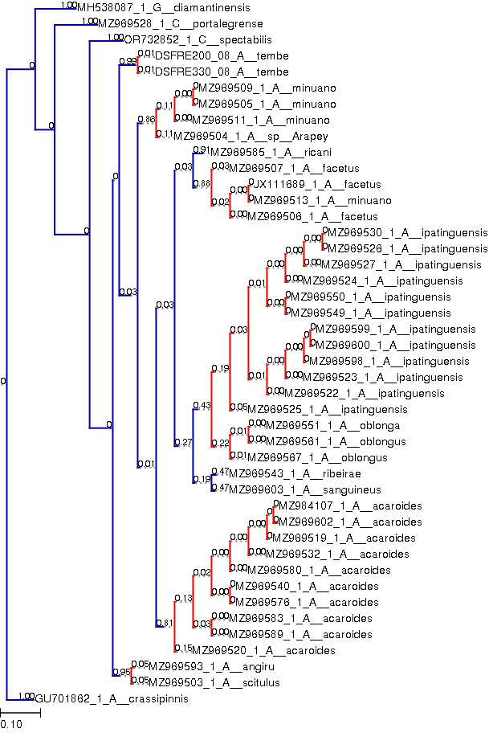
Fig. S1-4. Species delimitation result of analysis 4 for the COI gene, using Geophagus diamantinensis as outgroup, according to the bPTP method. *Blue lines represent delimited species and red lines represent intraspecific coalescence events.
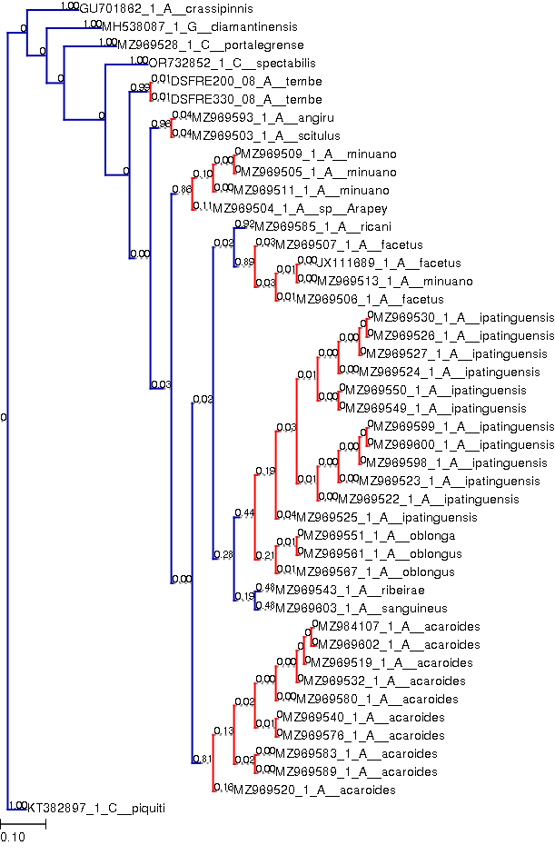
Fig. S1-5. Species delimitation result of analysis 5 for the COI gene, using Astronotus crassipinis as outgroup, according to the bPTP method. *Blue lines represent delimited species and red lines represent intraspecific coalescence events.

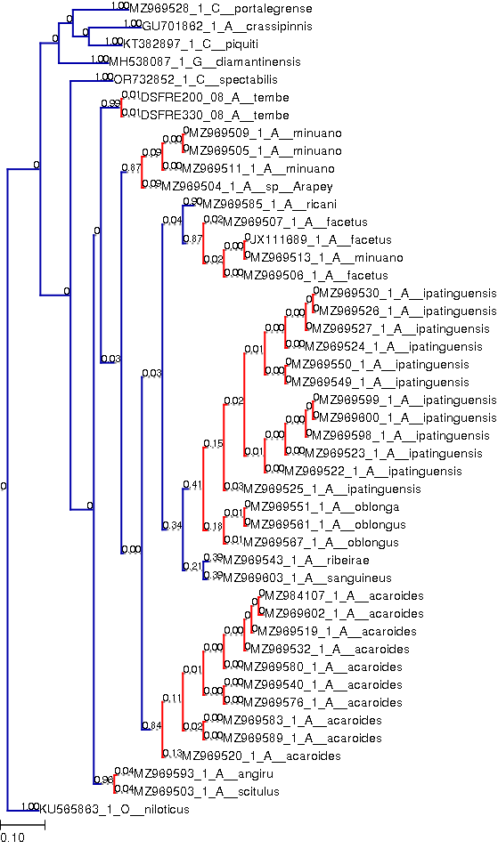
Fig. S1-6. Species delimitation result of analysis 6 for the COI gene, using Cichla piquiti as outgroup, according to the bPTP method. *Blue lines represent delimited species and red lines represent intraspecific coalescence events.
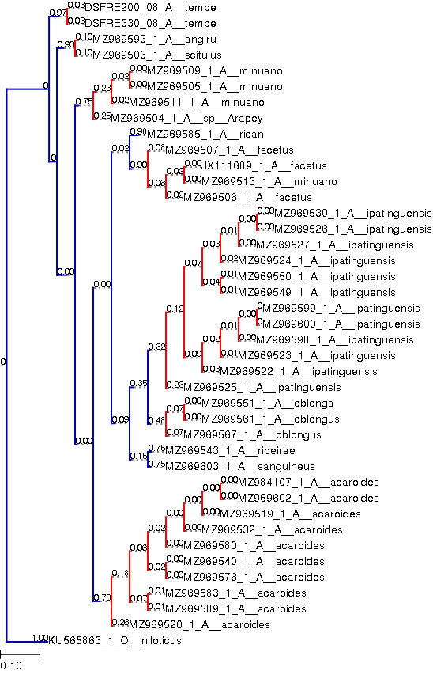
Fig. S1-7. Species delimitation result of analysis 7 for the COI gene, using Oreochromis niloticus as outgroup, according to the bPTP method. *Blue lines represent delimited species and red lines represent intraspecific coalescence events.
Fig. S1-8. Species delimitation result of analysis 8 for the COI gene, using Oreochromis niloticus as the only outgroup, according to the bPTP method. *Blue lines represent delimited species and red lines represent intraspecific coalescence events.

